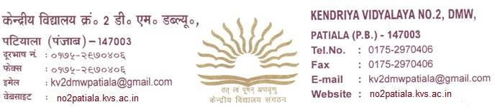

Registration Form For Class XI

1. Name of student ……………………………………
2. Date of Birth ……………………………………….
3. Father’s Name …………………………………….
4. Mother’s Name………………………………………
- Result of Class Tenth (X) with year of Passing ……………………………….
Previous Class with section ……………………………………………………..
- Details of Marks obtained: -

Subject Marks obtained
English Hindi / Skt.
Maths (Basic/standard) Science
Social Science
Percentage (Excluding Punjabi)
- Stream in which admission sought in order of preference: (i)
(ii)
- Subject to be taken: -
1. 2. 3.

4. 5. 6.

- Father’s/Mother’s Occupation (Designation) with Official Address and Telephone/Mobile No.

…………………………………………………………………………………………
- Residential Address
………………………………………………………………………………………… Telephone No. …………………………… Mobile No. ………………………….. Email ID……………………………………………….
Aadhaar Card no……………………………… Blood group……… Religion…………..
11. Whether SC/ST ………………………………………………………………..
- Whether played at Regional, National, SGFI Level (Attach copy of Testimonial/Certificate)
- Whether received Rashtrapati Award, Rajya Puraskar in Scout & Guide (Attach Certificate)

I hereby declared that the data given in Column 1 to 13 is correct to best of my knowledge.

(Signature of Parents) Signature of Student
Class and Section…………………
Dated ……………………….

Remarks of Admission In charge
Certified that I have checked the registration form and relevant papers and found it in order for admission to Class XI. Students are eligible for Science/Humanities/ Commerce with following subjects as per KVS Rules.
1. 2. 3.

4. 5. 6.

Signature of Admission In/charge

Principal Remarks

Admit ……………………….. to Class XI Section …………………….

Dated …………………………

Signature of Principal

Note:-The students are required to submit this form in the reception area of school between 9:00 AM to 11:00 AM

