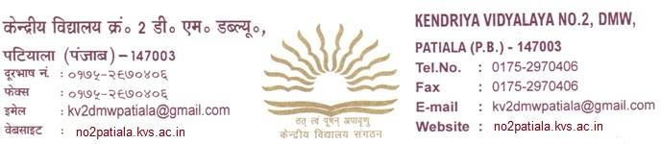

ADMISSION NOTICE-XI (2021-22)
(FOR STUDENTS OF KV 2 DMW, PATIALA)

- SUBMISSION OF REGISTRATION FORM TILL 12/08/2021
- DISPLAY OF ADMISSION LIST – 16/08/2021
- COMMENCEMENT OF ADMISSIONS- 17/08/2021 TO 23/08/2021

NOTE: REGISTRATION FORMS ARE AVAILABLE AT THE MAIN GATE OF VIDYALAYA.

LIST OF DOCUMENTS TO BE ATTACHED: -
- PHOTOCOPY OF MARKS SHEET Class X
- CASTE CERTIFICATE (IF APLICABLE)
Subjects offered in different streams-
SCIENCE STREAM
COMPULSORY SUBJECTS- ENGLISH, PHYSICS, CHEMISTRY, MATHEMATICS (NON MEDICAL), BIOLOGY (MEDICAL)
OPTIONAL SUBJECTS- HINDI/COMPUTER SCIENCE
COMMERCE STREAM
Compulsory subjects- English, Accountancy, Business Studies, Economics.
Optional Subjects- Hindi/I.P./ Mathematics
Humanities Stream-
COMPULSORY SUBJECTS-English, Hindi, Geography, History
OPTIONAL SUBJECTS- Political Science/ Economics
ADITIONAL SUBJECT- PHYSICAL EDUCATION (Science, Commerce, Humanities Streams)

(Principal)

